C Language By Kaushal Bhatol

Operators [Week 1, 08]:
An Operators is a symbol used to perform operations in given programming language.

==> types of operators
- Arithmetic operators
- Relation Operators
- Logical Operators
- Bit-wise operators
- Assignment operators
- Miscellaneous

- Arithmetic operator [week 1 : 08.1]

This operators are basic operators for day to day life.

Operators | Description
+ | Addition
- | Substraction
* | Multiplication
/ | Divison
% | modulas

- Relation operator [week 1 : 08.1]

Operators | Description
== | Is equal to
!= | Is not equal to
> | Greater than
< | Less than
>= | Greater than
<= | Less than or equal to

Note : mostly this operators are used in if, else statement.

- Logical operator [week 2 : 08.2]

Operators | Description | Example
&& | Logical “AND” operator, both the operands are non-zero then condition is true. | a&&b
|| | Logical “OR” operator, if any of these two operands is none-zero, Then condition become true. | a||b
! | Logical “NOT” operator, It is used to reverse the logical state of its operand, if condition is true.. | !a

- Bit-wise operator [week 1, 08.2]

bit-wise operator are functioning on bit.

Value A | Value B | A&B | A|B | A^B
0 | 0 | 0 | 0 | 0
0 | 1 | 0 | 1 | 1
1 | 1 | 1 | 1 | 0
1 | 0 | 0 | 1 | 1

Symbols Names
& AND
| OR
^ Exclusive (XOR)

-XOR Operator--> If one value is true and second one is false, Then XOR give true value.

- ->other Bit-wise operators
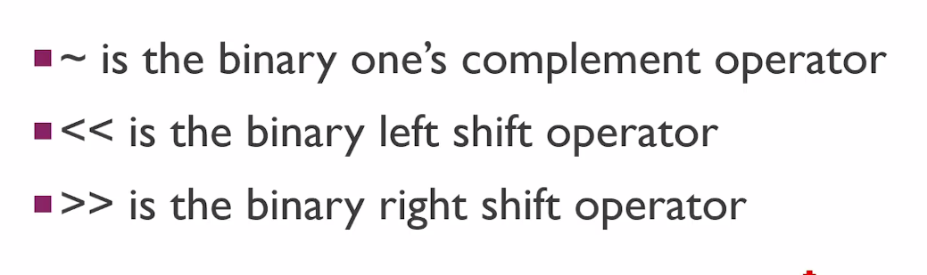

- Assignment operator

Operators | Description
= | Simple assignment operator assign value from right side operands
+= | Add AND assignment operator. It’s adds the right operand to the left operands and assign the result to the left operands
-= | Subtract AND assignment operator. It subtracts the right operands from the left to the result is assignment to the left operand.
*= | Multiply AND assignment operator. It multiples the right operands from the left to the result is assignment to the left operand.
/= | Divide AND assignment operator.It divide the right operands from the left to the result is assignment to the left operand.

- Miscellaneous

Operators | Description | Example
sizeof() | Returns the size of variable. | sizeof(a), where a is a integer, will return int’s size on that architecture .
& | Returns the address of a variable. | &a; returns the actual address of the variable.
* | Pointer to variable | *a;
?: | Conditional Expression | If condition is true? The value X: otherwise value Y

#. Operators PRECEDENCE IN C
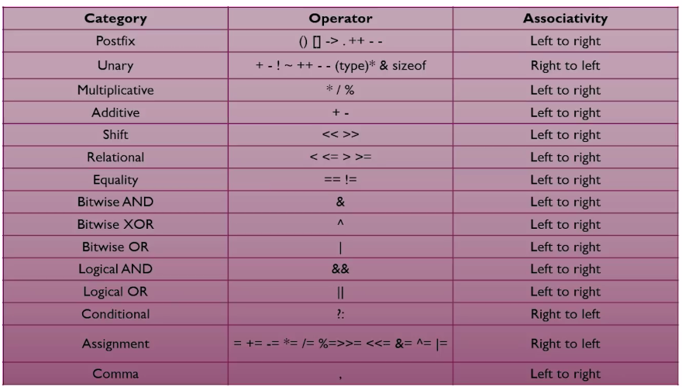

Format specifiers [week 1, 09]
Format | Work
%c | Character print
%d | Integer print
%f | Float print
%l | Long print
%lf | Double print
%LF | Long Double print

-> Format specifiers is a way to tell the compiler what type of data I sin a variable during taking input and displaying output to the user.
-> Pritf(“This is a good boy %a.bf”, var); will print vvar with b decimale in a “a” character space

-Exp->
- Week 1, 09 .c file

float c= 6.333
Printf(“%7.4f”, c);

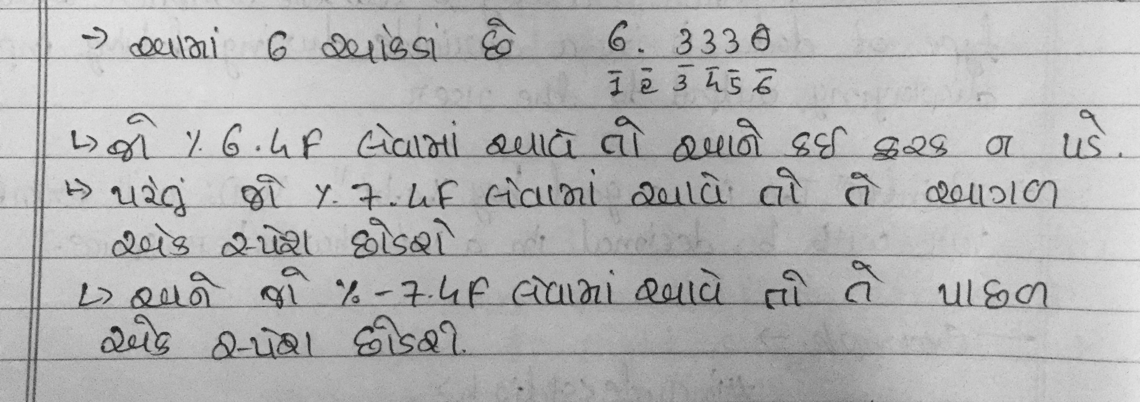

-> Note: 0 is always included in format
-> It work with - also.. exp: %-2.2f
->It only work if value is less then applied specifier. Else it show real values.

Constant [Week 1, 10]
-> A constant is a value or variable that can’t be changed in the program.

Example: 15, ‘a’, 3.4, “Name, etc..

-> There are Two ways to define constant in C Program.
- Constant Keyword
Exp: const float b = 7.499;
- #define preprocessor
Exp: #define PI 3.14

Escape sequence[Week 1]
-> an escape sequeance inn C programming, languaage is a sequance of characters.
-> It dosen’t represent itself when used inside string literal or character.
-> It is composed of two or more characters string with backslash \.
